Thermocouple Sensor Array Setup Guide

Tony Tu – Engineering Intern

05/02/2026

Table of Contents

01 | Project Setup 3

1.1 MCU (Microcontroller Unit) Connections 3

2.1 Ribbon Cable Connection 4

3.1 USB Hub and Laptop Connections 4

4.1 Thermocouple connection 6

02 | Thonny Setup 7

03 | VS code setup 11

04 | Browser Setup 16

05 | Thermocouple Selection and Position Setting 19

5.1 Configuring position VIA CSV. 20

06 | Thermocouple Data Measurement 23

07 | Reviewing data from previous files. 26

08 | Features of viewing a file 29

09 | Debugging 32

6.1 Resetting Software 32

7.1 Full reset of local storage on browser 34

10 | Common Issues 35

11 | Requirements 38

12 | How to debug and add new features easily: AI 39

# 01 | Project Setup

## MCU (Microcontroller Unit) Connections

**CRITICAL: Make sure the USB Hub (see Figure 3) is not plugged into the laptop before doing this step.**

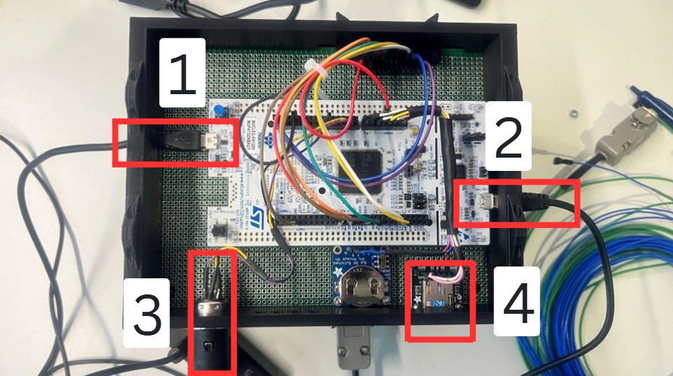Plug connection 1-3 into the 3D printed box as shown below in Figure 1:

Figure 1: Microcontroller connections.

**Label 1:** Micro USB connection to allow the E: drive to be seen.

**Label 2:** Micro USB connection to power the MCU.

**Label 3:** DIN connector (3 Pin) – this connection should feel intuitive.

**Label 4:** MICRO SD card connection – this connection should not be touched as the SD card should already be in.

**IMPORTANT**: When connecting label 1, make sure the “teeth” are facing downwards.

**IMPORTANT**: When connecting label 2, make sure the “teeth” are facing upwards.

## Ribbon Cable Connection

Connect the 26 Pin IDC connectors up. An example of the connection is shown in Figure 2.

Push the IDC connectors in until both the side flanges click and fold in.

**IMPORTANT:** Label **1** will always need to be connected in.

To enable **16 thermocouples**, **labels 1 and 2** must be connected.

To enable **32 thermocouples**, **labels 1, 2** and **3** must be connected.

**IMPORTANT:** The system will not work if labels 3 and 1 are connected.

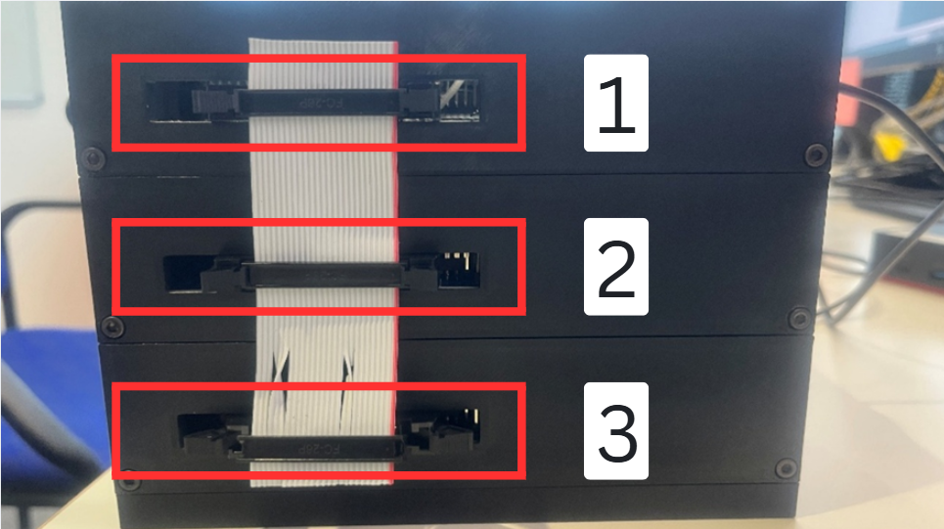

Figure 2: Ribbon cable connections.

## USB Hub and Laptop Connections

Plug the USB connectors (labelled 1 and 2 from Figure 1) into the USB hub, as shown in Figure 3.

**IMPORTANT:** Make sure that the USB hub’s plug is not connected to the laptop before this step, if so unplug first.

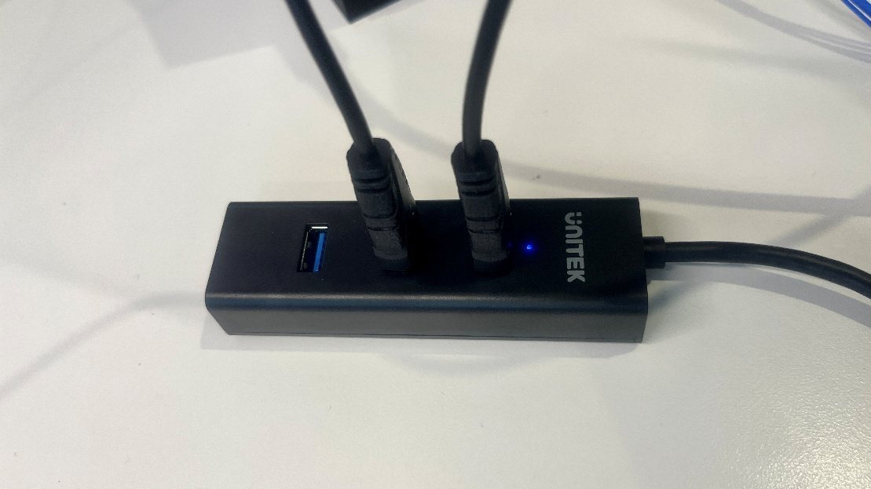

Figure 3: USB hub connection

**IMPORTANT:** Ensure the USB connectors are plugged into the USB hub **first** (see Figure 3) and then continue. I.E Do not plug the USB hub’s connector into the laptop unless your USB hub looks like Figure 3.

**IMPORTANT: DO NOT connect the USB plug of connection 1 and 2 from** Figure 1 **directly into your laptop ports. Ensure they are plugged into the USB hub!**

Plug the USB hub’s plug (label 2) and the DIN connector’s USB plug (label 1) to your laptop as shown Figure 4.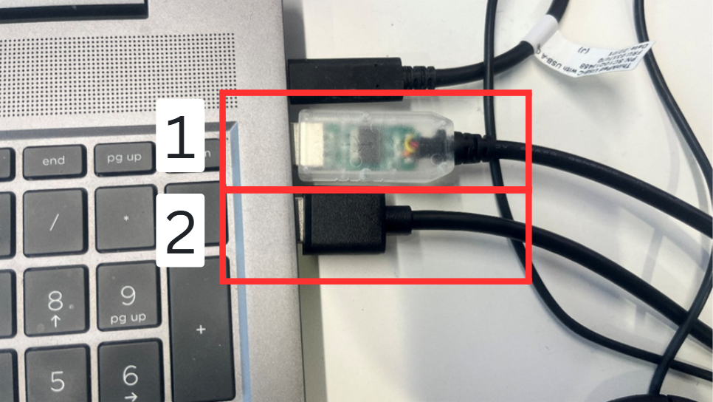

Figure 4: USB plugged into the laptop.

## Thermocouple connection

Plug the thermocouple D-Subs into the sensor input connectors. (See Figure 5).

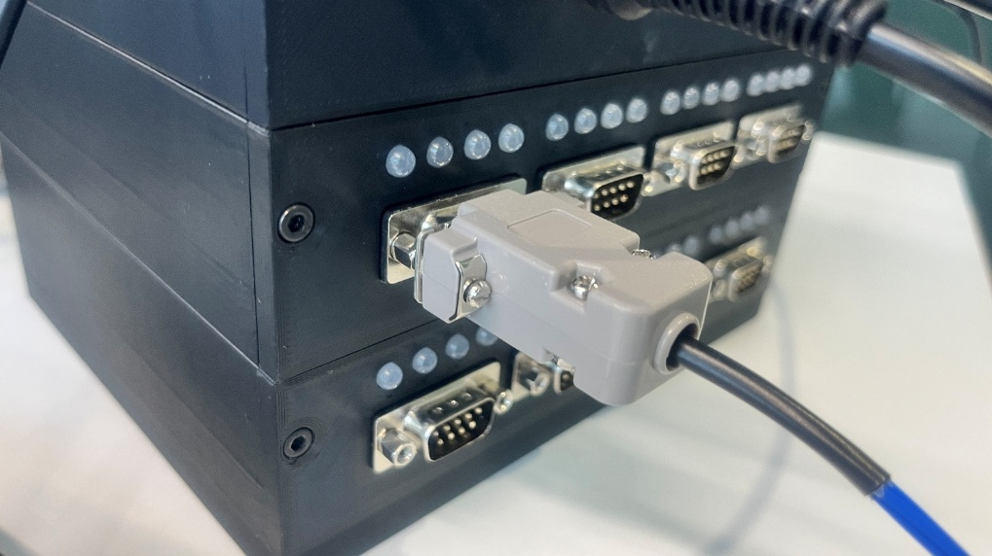

Figure 5: Inserting the D-Sub connector in.

# 02 | Thonny Setup

Launch Thonny on the laptop

Check that the text in Thonny matches what is shown near label 2 in Figure 6.

The exact text is:

**“MicroPython v1.27.0-preview.12.gb1d5c656d.dirty on 2025-08-25; NUCLEO-F413ZH SDCARD V0.5 with STM32F413**

**Use front USB connector to access SD-Card from PC**

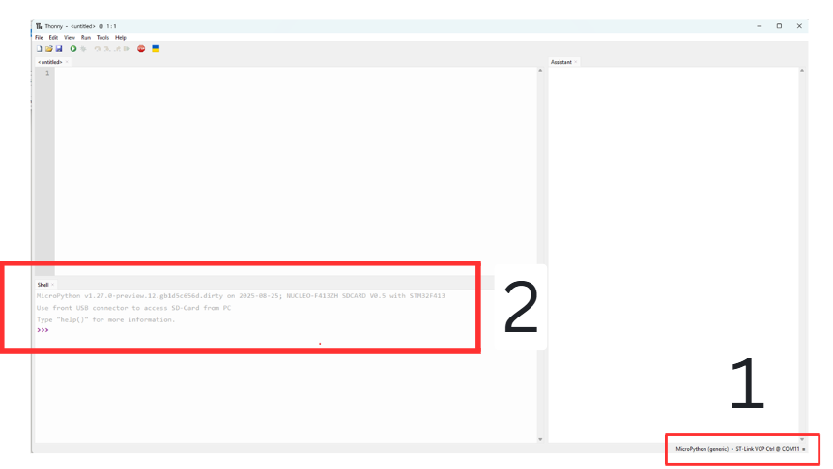**Type "help()" for more information.”**

Figure 6: Thonny IDE on launch.

If the text does not match, click the text displayed near label 1 shown in Figure 6.

When you do, all the COM ports (Communications Port) will appear, as shown in Figure 7.

Find and click on the line “MicroPython (generic) ST-Link VCP Ctrl @ COM11” or similar**.**

**NOTE:** The COM number (e.g., COM11) will vary between devices, so choose the line that begins with “**MicroPython (generic) ST-Link VCP Ctrl @** “.

**IMPORTANT:** This will not appear if the connection labeled 2 in Figure 1 is not plugged in.

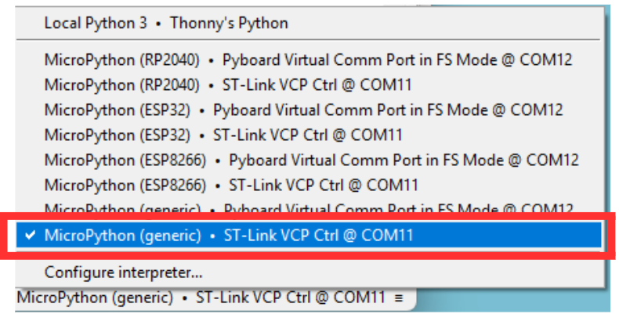

Figure 7: Thonny’s COM port list.

**IMPORTANT: The following steps are CRITICAL.**

**IMPORTANT: Do not attempt to open the Python file directly from the E: drive through the File Explorer.**

* Click **File,** then **Open. (**Figure 8**)**
* The Thonny IDE should then appear as shown inFigure 9**.** 
  + If the IDE does not look likeFigure 9**,** check the MICROUSB connections.
* Click **MicroPython Device**, scroll down and the IDE should resembleFigure 10
* Select the **state_machine.py file,** click OK and the IDE should then appear as shown inFigure 11**.**

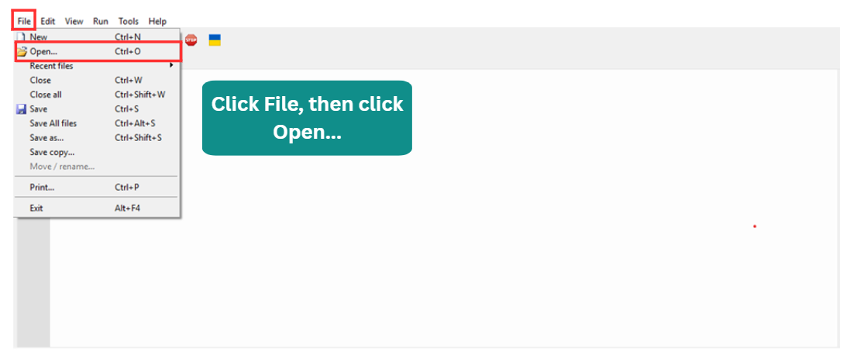

Figure 8: Click **File** and then **Open…**.

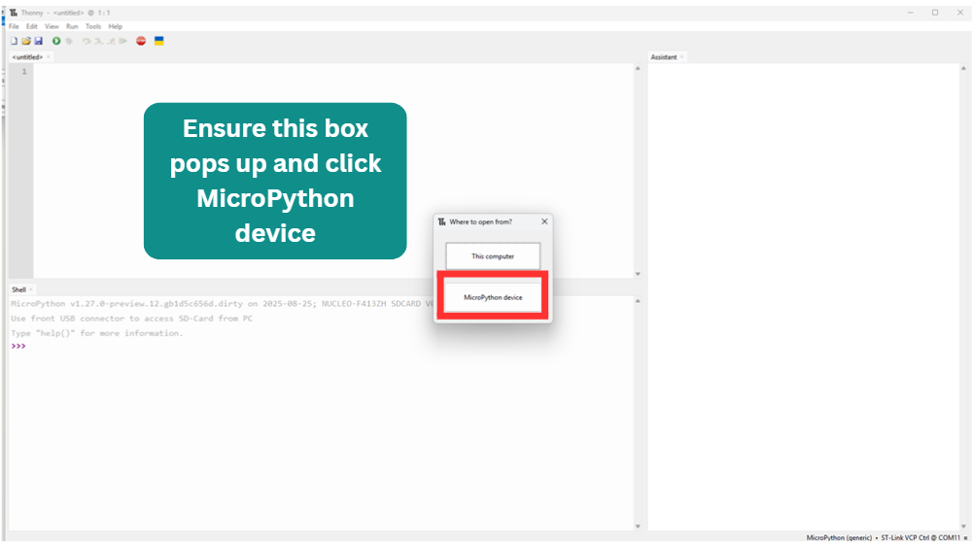

Figure 9: Click **MicroPython devices**.

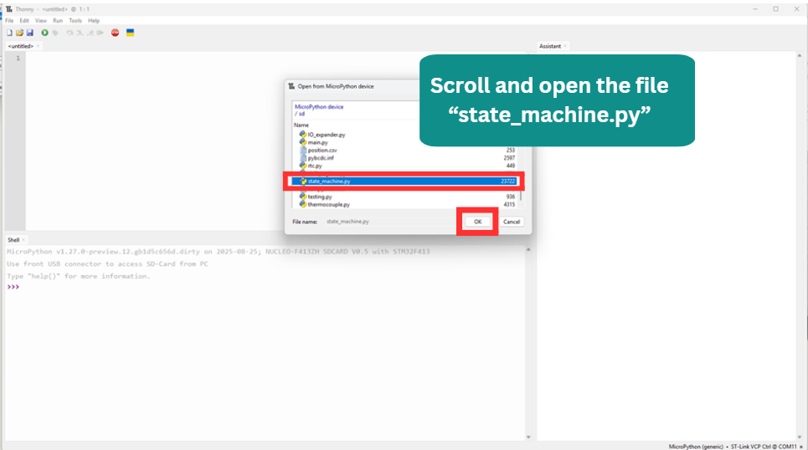

Figure 10: Find the **state_machine.py** file and click **OK.**

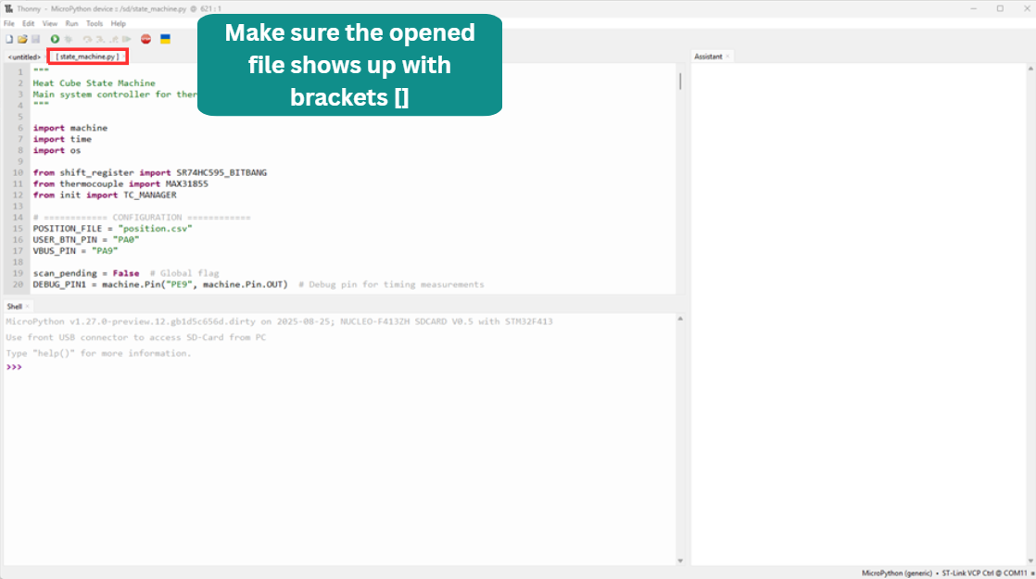

Figure 11: Ensure that the opened file has []. I.E [state_machine.py].

# 03 | VS code setup

Launch VS code:

Click **File**, and the menu shown in Figure 12 will appear. Select **Open Folder…**

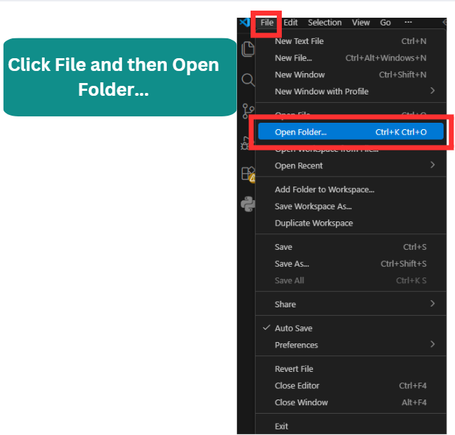

Figure 12: Click **File**, then **Open Folder…** on VS Code.

After clicking **Open Folder,** locate and click on the **heat_cube** folder then click **Select Solder.** Figure 13shows an example of this step.

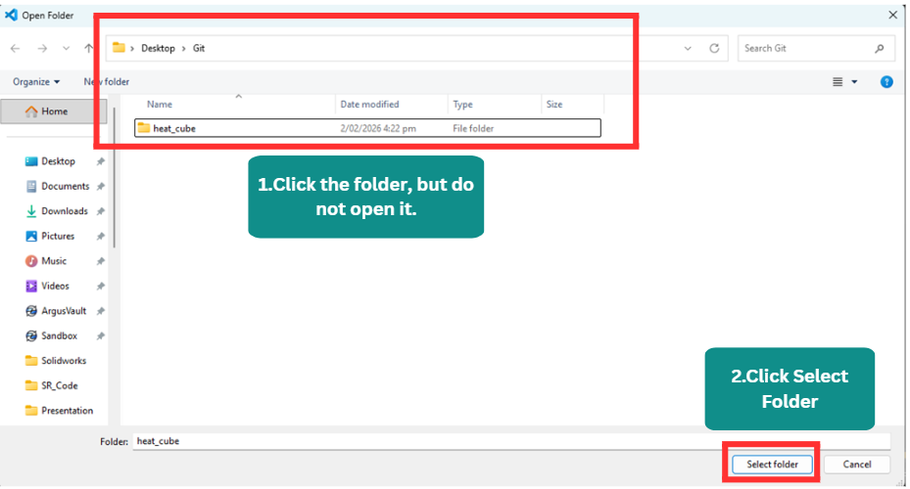

Figure 13: After clicking open folder on VS code.

After selecting the folder, the Explorer view should appear as shown in Figure 14.

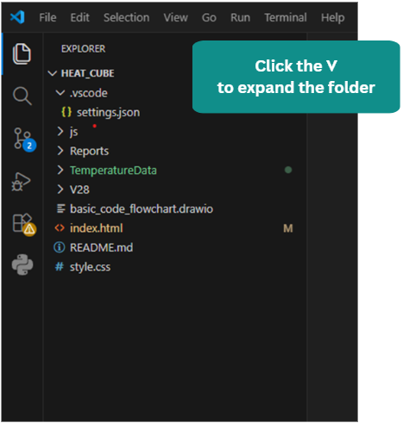

Figure 14: Files and folders within the heat_cube folder.

Right-click the file **index.html** and click **Open with Live Server. (**Figure 15**).**

**NOTE: This step requires the Live Server extension to be installed in VS Code.**

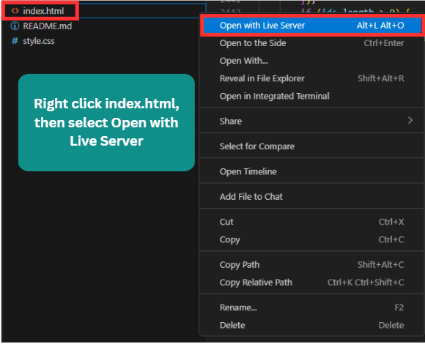

Figure 15: Right the **index.html** file and click **Open with Live Server**.

The browser will open automatically. If this is your first time launching it, you may see a browser like Figure 16. Click **Enter Visualiser** to continue.

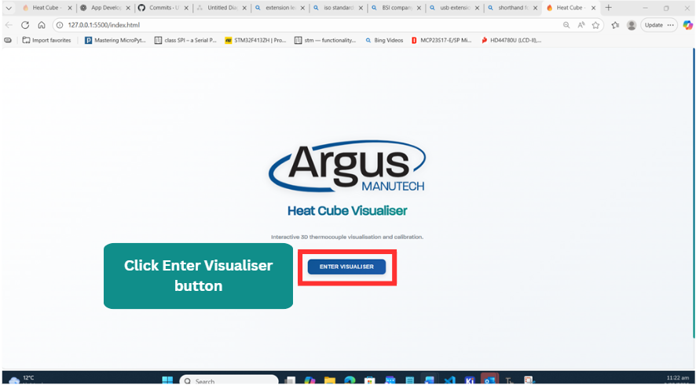

Figure 16: Initial browser interface.

Open the terminal. If the terminal is not visible, click the icon shown near label 1 in Figure 17 marked with an **“X” inside a circle and a warning triangle**, then click **Terminal** as shown near **label 2**.

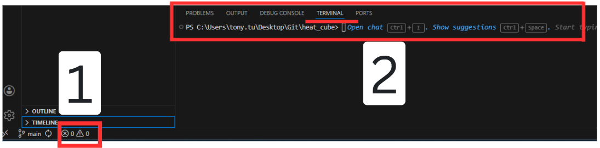

Figure 17: VS Code terminal

In the terminal, you **must** be inside the ***heat_cube/js*** folder.

If the terminal appears as shown in Figure 18, navigate into the **js** folder.



Figure 18: VS code terminal in the wrong folder.

To enter the **js** folder, type cd js. If you navigate into the wrong folder, type cd .. to move back one level.

This is illustrated inFigure 19**.**

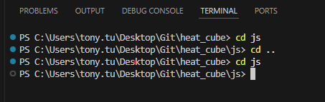

Figure 19: Terminal commands.

Once your terminal PS (Power Shell) is in the correct folder type **node copy-backend.js**. A message like the one shown inFigure 20 will appear.

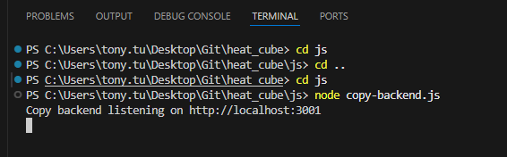

Figure 20: Typing commands into the terminal.

# 04 | Browser Setup

Once the **Enter Visualiser** button is clicked, a screen similar to Figure 21 will appear.

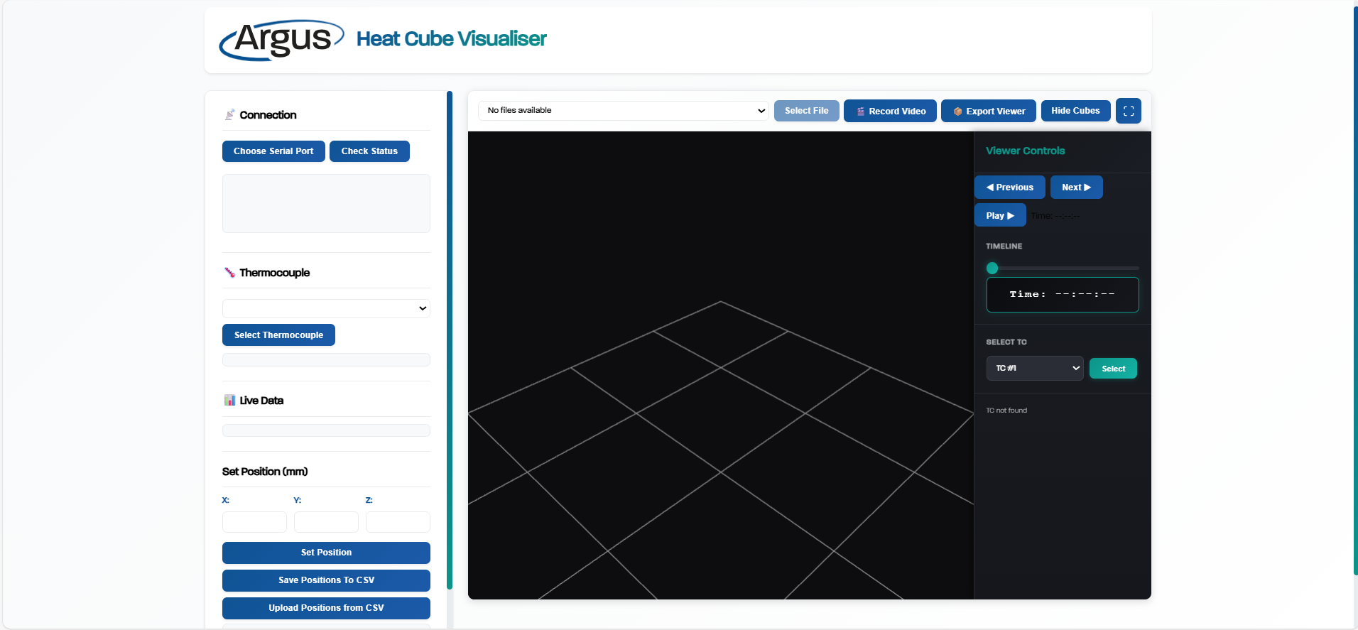

Figure 21: Initial browser screen.

In Thonny, click the green Run button to start the Python code. Text like that shown in Figure 22 will appear in the Python shell.

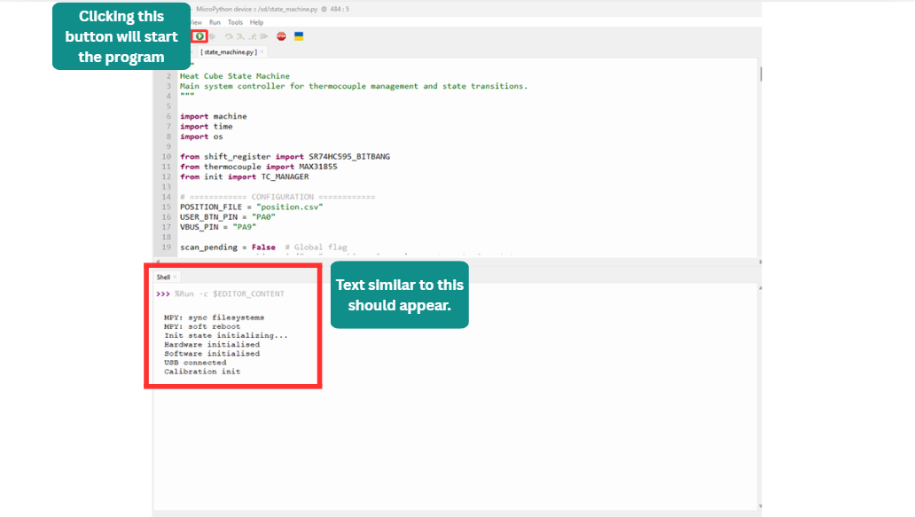

Figure 22: Starting the Python program.

For the initial setup, click the **Choose Serial Port** button. A popup like the one shown in Figure 23 will appear.

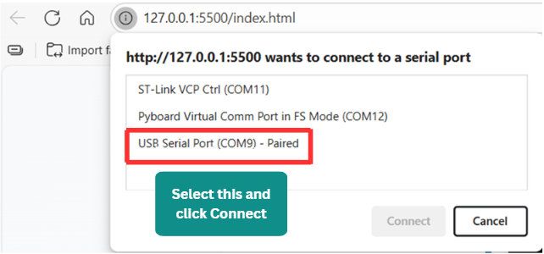

Figure 23: Serial port pop up selection.

Select the appropriate serial port, which in this example (shown in Figure 23) is **USB Serial Port (COM9)** and click **Connect**. The serial port only needs to be paired once, every other time it will automatically connect.

Figure 24 and Figure 25 show the browser and the Thonny terminal after the serial port has been connected.

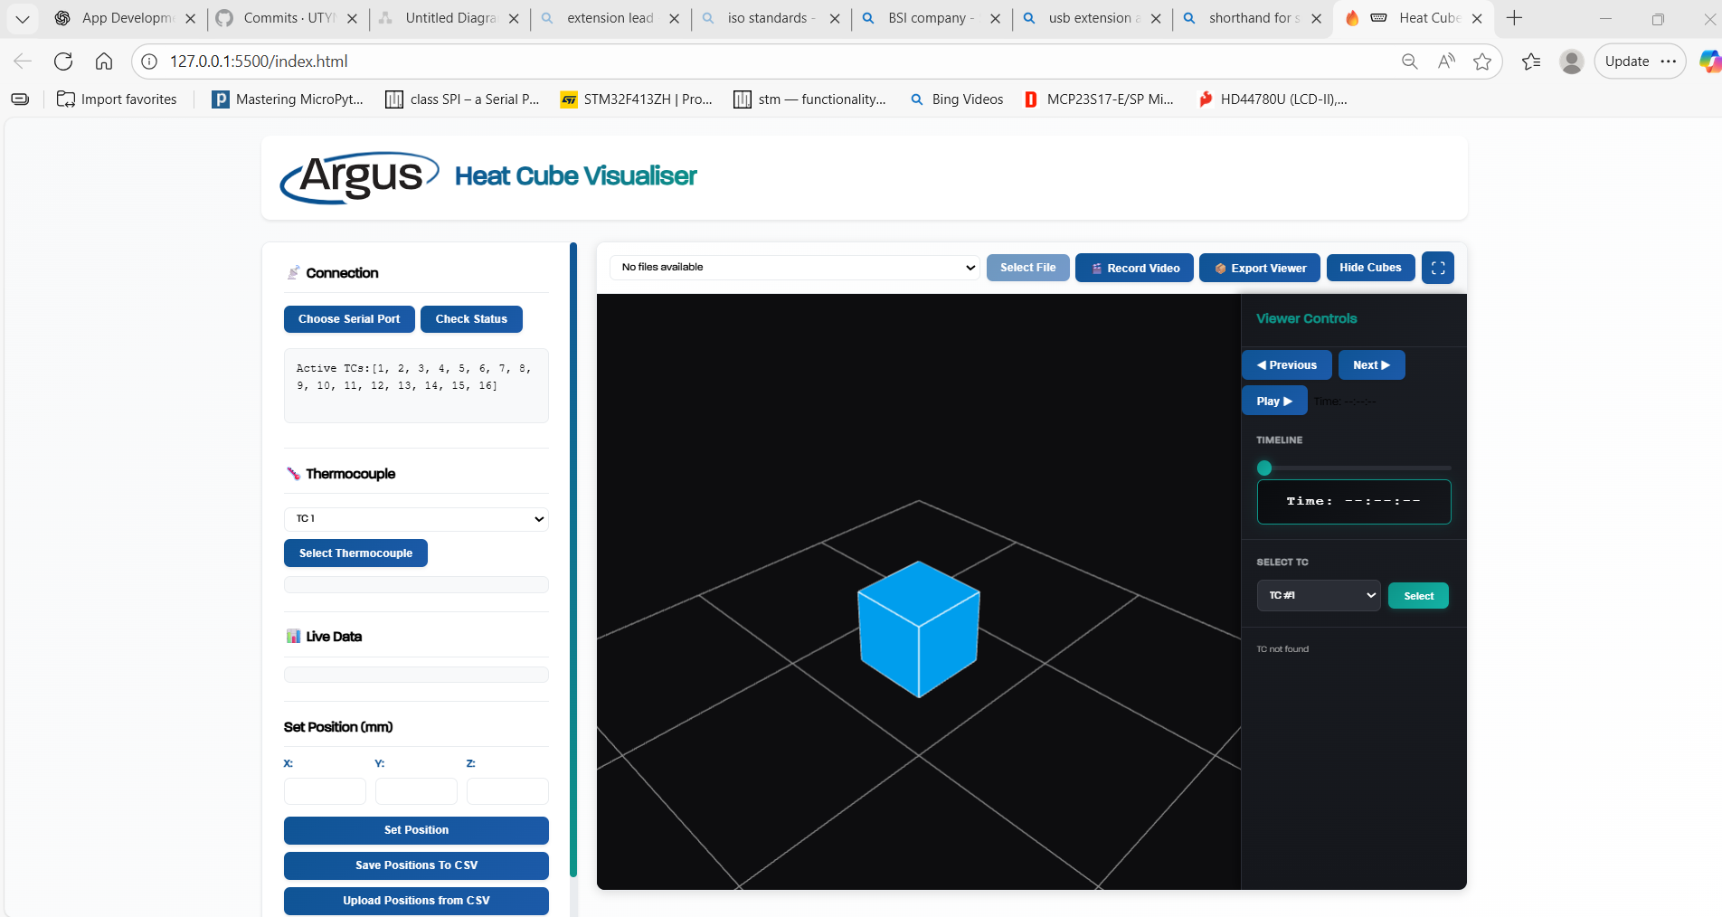

Figure 24: Browser view after choosing Serial Port.

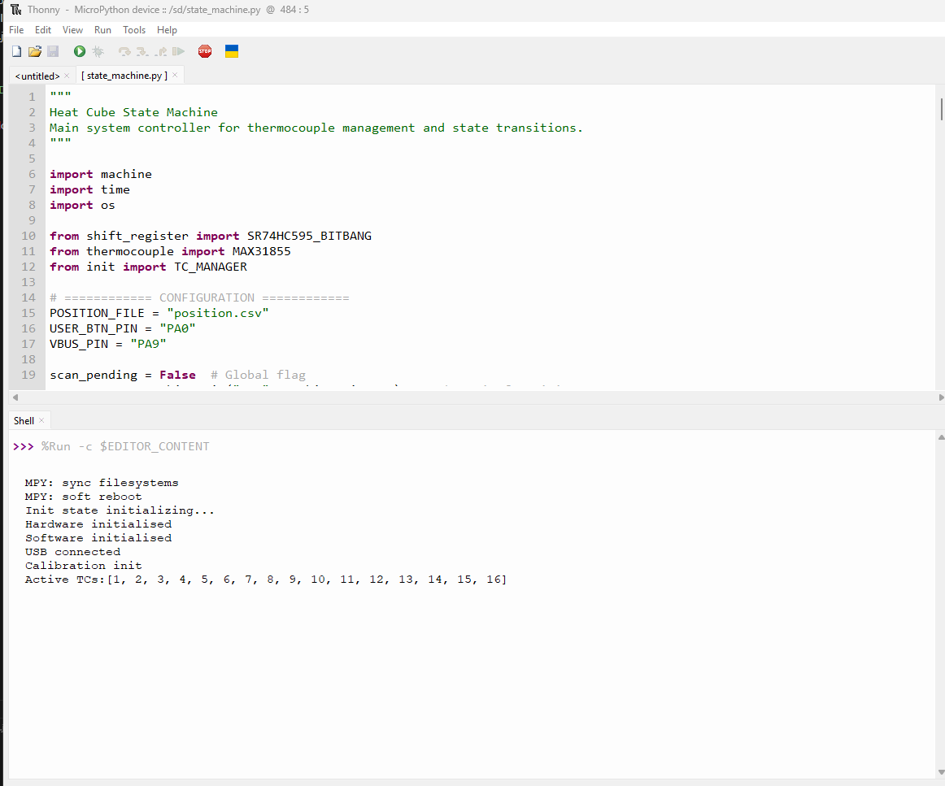

Figure 25: Thonny IDE after connecting to serial port.

# 05 | Thermocouple Selection and Position Setting

This section explains how to select thermocouples and set their positions.

To select a thermocouple, you can:

* Click the drop down shown near label 1 in Figure 26 and click **Select Thermocouple**.
* Hover and click a thermocouple cube shown in near label 7 Figure 26.
  + Note if multiple cubes are overlapping each other this cannot be done.

After selecting a thermocouple, its LED starts flashing, and when the selected probe is touched, its temperature updates in the Live Data section (label 2) and the colour of the corresponding cube changes (label 7).

To set the positions of the thermocouple, you can:

* Type in the X, Y and Z values in the fields shown near label 3, click **Set Position** button (label 4). The current X, Y and Z positions of the selected cube will automatically load in the text fields.
* Click the **Upload Positions from CSV** button near label 6.
  + This assumes that the correct number of thermocouples is connected and that the **position.csv** file has been filled out correctly. See 5.1 for instructions.

After setting the positions of all the thermocouples, click **Save Positions To CSV** (label 5) to save the positions into the **position.csv** file.

NOTE: If you want to stop the flashing light click on the **Set Position (label 4)**.

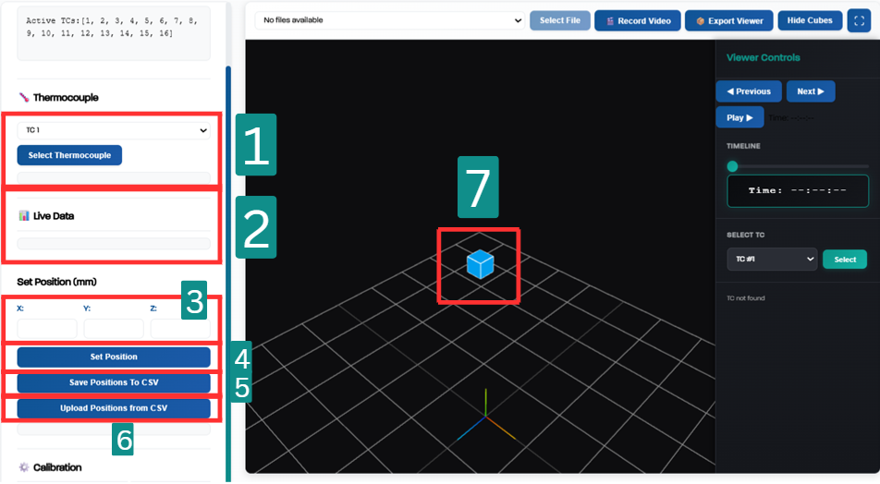Figure 26: General layout of the browser.

## Configuring position VIA CSV.

The following steps outline how to set thermocouple positions via changing the **positions.csv** file.

**IMPORTANT:** Click the red Stop **button** in Thonny**.** The Thonny interface should then appear as shown inFigure 27.

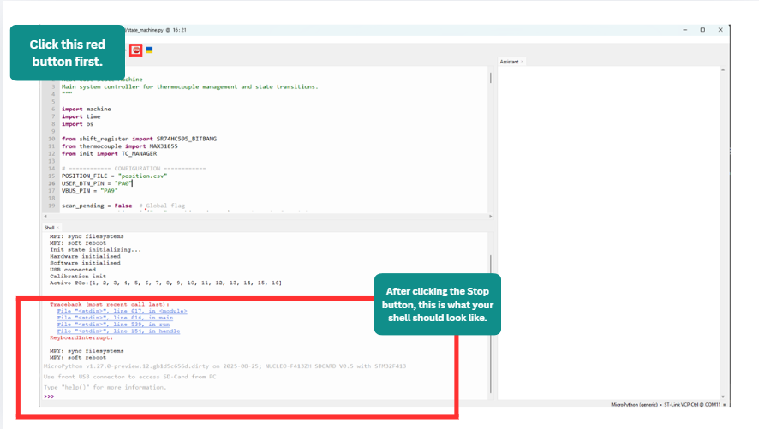

Figure 27: Thonny interface after clicking the red STOP button.

Press the MCU reset (**black button**) on the board, as shown in Figure 28.

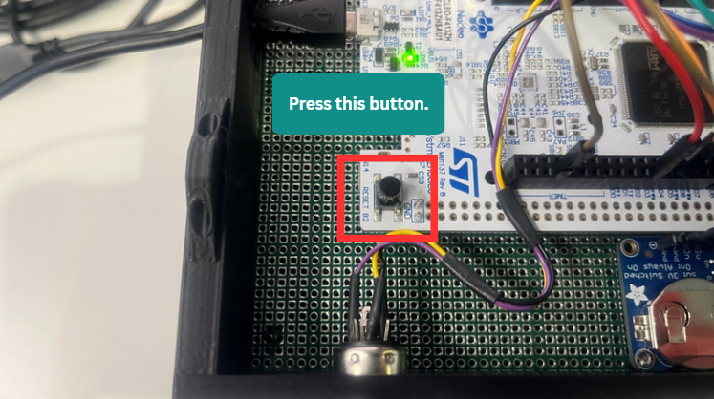

Figure 28: MCU reset button (black button) on the board.

**IMPORTANT:** Click the red Stop button again shown in Figure 27 to stop the code again.

Once the code has been stopped, locate and open the **position.csv** file on the E: Drive using File Explorer (see Figure 29).

NOTE: The E: Drive will not appear if the connection labelled 1 in Figure 1 is not connected.

The **first column** represents the **thermocouple number**, the **second column** represents the **X position**, the **third column** represents the **Y position**, and the fourth column represents the **Z position**. These columns are labelled in Figure 29 if unclear. The units are in cm.

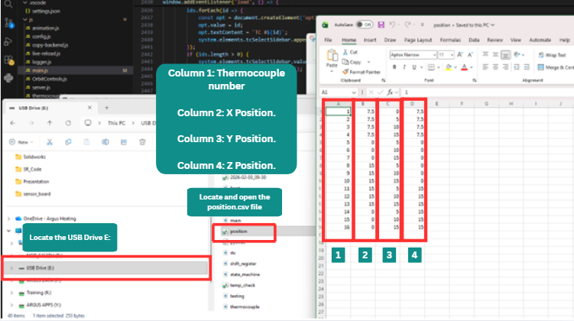

Figure 29: File format for position.csv file

After editing the position.csv file, save the file and click the Reset button on the MCU again (Figure 28).

**IMPORTANT:** Once pressed, the Thonny IDE should show messages as seen in Figure 25.

Click the **Upload Positions from CSV** button, and the cubes will update to the positions specified in the **positions.csv** file. An example of a configuration is shown in Figure 30.

NOTE: The white grid and axes may appear misaligned, as they are set using fixed values in the code.

**If scene is frozen then refresh the page.**

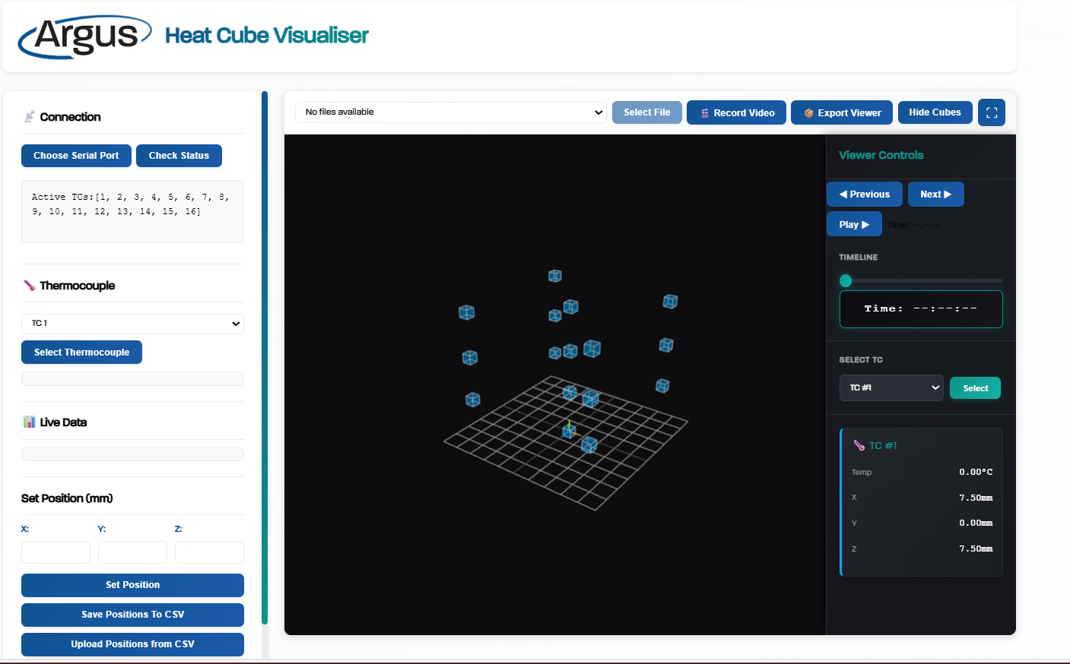

Figure 30: After clicking Uploading Positions from CSV button.

# 06 | Thermocouple Data Measurement

To start measuring data from the thermocouples, click the **Finish Calibration** button, as shown in Figure 31.

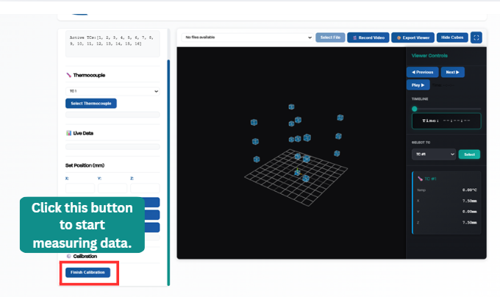

Figure 31: Button to press to start measuring.

When the **Finish Calibration** button is clicked, the LEDs on the PCB will flash.

The cubes on the screen will appear red if no thermocouples are connected, as shown in Figure 32.

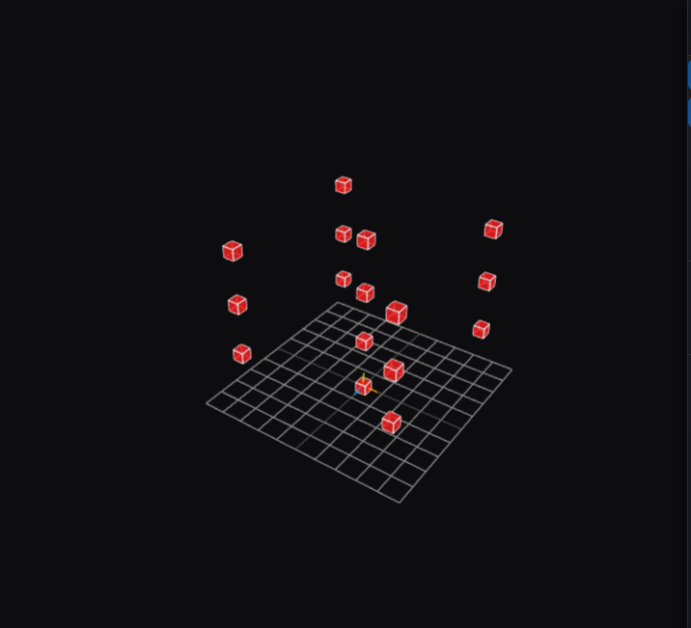

Figure 32: Red cubes represent that no connected thermocouples.

To stop measuring, click the **Enter Calibration Mode** button (see Figure 33).

The button will typically display **Enter Calibration Mode**, but in some cases, it may still show **Finish Calibration**. Regardless of the label, clicking the button will stop the measurement process if measurement is currently active. If the LEDs do not flash, measurement has stopped successfully.

NOTE: Do not click this button repeatedly rapidly; wait approximately 2 seconds for changes to take effect.

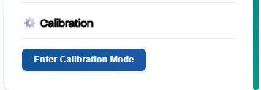

Figure 33: Enter Calibration Mode Button.

To confirm whether the system is in calibration mode or measurement mode, check the last message in the Thonny terminal (see Figure 34).

If the last message is **‘Calibration init’**, the system is in calibration mode.

If the last message is **‘Measure init’**, the system is in measurement mode.

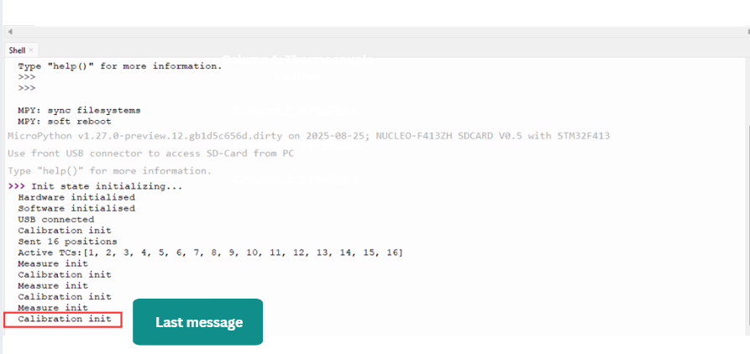

Figure 34: Thonny shell upon entering measurement mode and calibration mode.

# 07 | Reviewing data from previous files.

After thermocouple data has been measured and a file needs to be reviewed, follow the steps in this section.

Steps to check:

* Ensure the VS code terminal appears as shown in Figure 20.
* Ensure the Python shell appears as shown in Figure 34.

In the browser click the **Check Status** button, as shown in Figure 35.

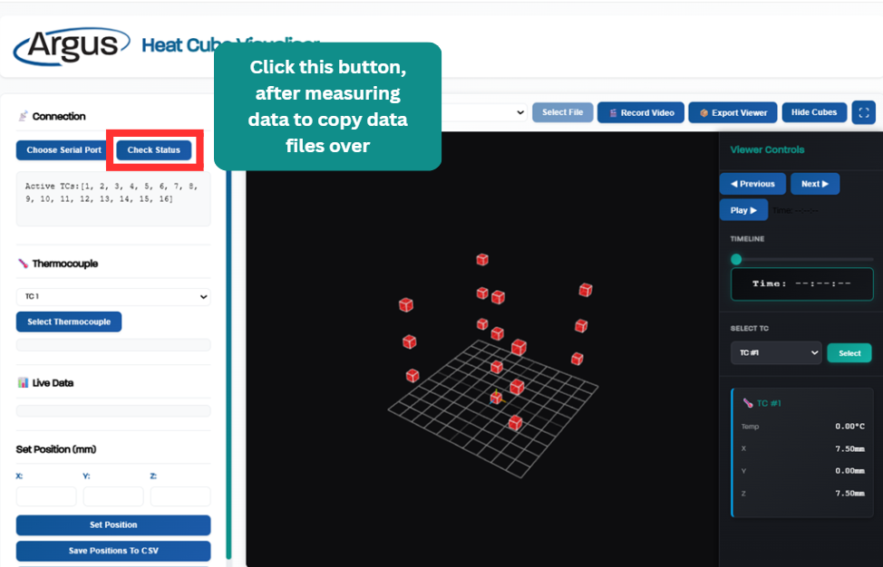

Figure 35: Check Status button.

Wait until the PowerShell (PS) terminal in VS Code displays text like that shown in Figure 36.

NOTE: Check the terminal messages to confirm that the recently recorded file has been copied over correctly.

NOTE: Wait until the last line displays **Backup complete.**

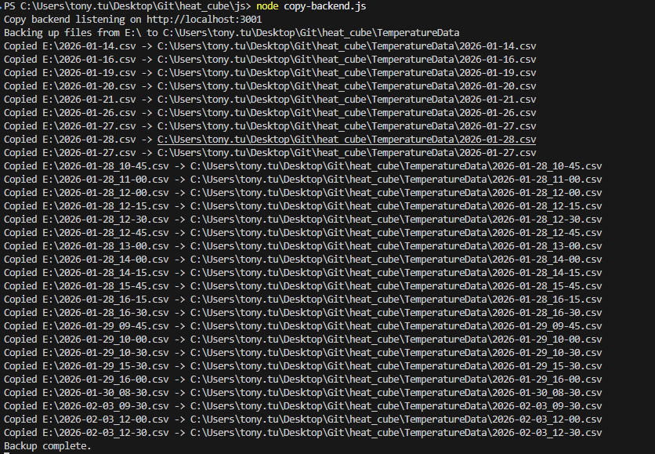

Figure 36: Power shell after launching node and clicking "Check Status".

Click the dropdown labelled “Select a file…” and select a file to view. Then click **Select File**. If the file that was just recorded does not appear, refresh the page.

Further explanation is shown in Figure 37.

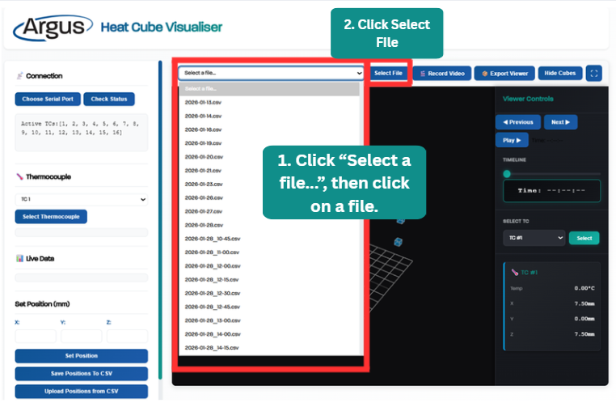

Figure 37: After clicking “Select a file...”

After this, the textbox will display information like that shown in Figure 38.

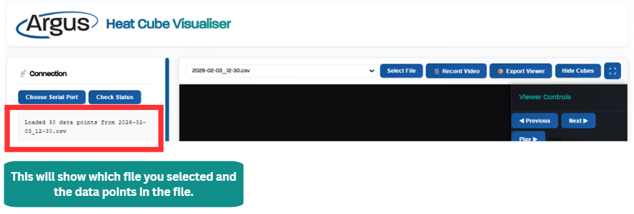

Figure 38: After clicking Select File.

# 08 | Features of viewing a file

This section covers the available features after a file has been selected for review.

Figure 39 shows the features available when reviewing a file.

The Feature Buttons section includes the following features:

* **Record Video** button – Click to record a video of the scene.
  + This recording will capture any scene movement, including rotation, panning or zooming.
* **Export Viewer** button – Click to generate a standalone HTML file containing the same data points as the selected file.
  + The HTML file is downloaded to the **Downloads** folder.

NOTE: The **Record Video** feature is not recommended for large files, as recording may take a significant amount of time. The **Export Viewer** feature is recommended instead.

The Viewer Controls section includes the following features:

* **Previous**, **Next** and **Play** buttons:
  + **Previous -** Displays the previous data.
  + **Next** – Displays the next data.
  + **Play** – Plays through all the data, starting at the time displayed in the **Time Box**.
* When **Play** is clicked, the button text will change to **Pause.**
  + **Pause –** Stops the playback of data.
* **Timeline Scroller –** Scroll the timeline forward or backward to view the data associated with the time displayed in the **Time Box**.
* **Select TC Section:**
  + NOTE: This control is used for viewing the data of a specific thermocouple from a file.
  + Selecting a thermocouple in this section does not allow configuration of its position.
* **Hide Cubes** button – Hides all cubes in the scene.
* **Full screen icon** – Displays the scene in full-screen mode.

NOTE: Drag the Timeline scroller back if the scene isn’t changing when clicking the **Play** button.

NOTE: Remember to click **Pause** if you want to stop the playback.

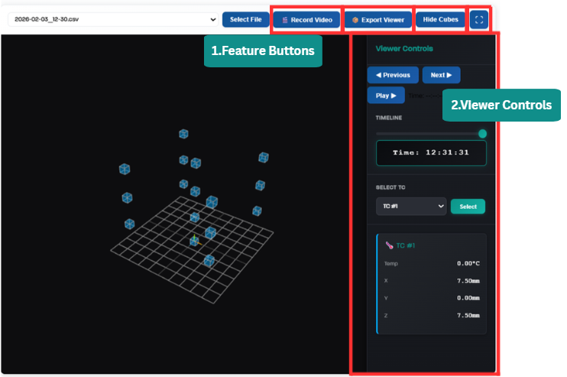

Figure 39: Features on the browser

Figure 40 illustrates what occurs when the **Export Viewer** button is clicked.

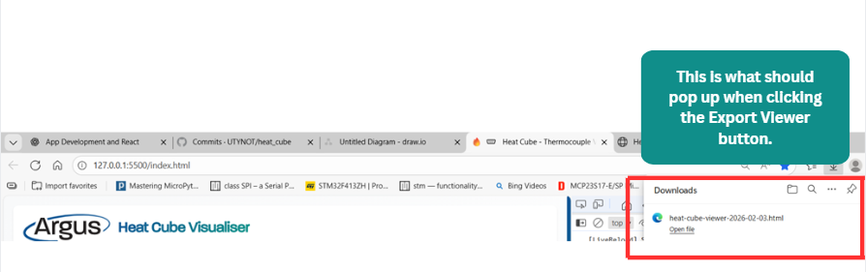

Figure 40: Clicking export viewer.

After opening the exported HTML file, a black scene may appear initially, as shown in Figure 41. Zoom out to view the scene.

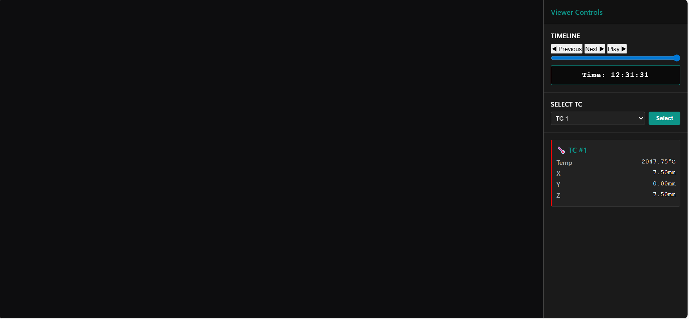

Figure 41: Clicking the downloaded html link.

After zooming out, the scene will appear similar to Figure 42. This exported HTML file also includes additional viewing features. These features are the same as those in the **Viewer Controls** section on the original page.

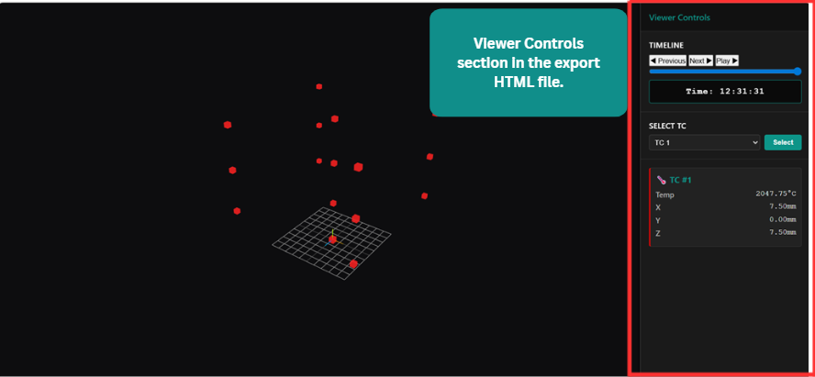

Figure 42: Zooming out in downloaded HTML file.

# 09 | Debugging

This section covers ways to debug when the system is faulty.

## Resetting Software

Remove a blank line or make any small change in the **HTML, CSS,** or **JavaScript** files, then press **Ctrl + Z** to revert the change. This will refresh and reload the page.

Refresh the page and/or click the **Check Status** button. (See Figure 43).

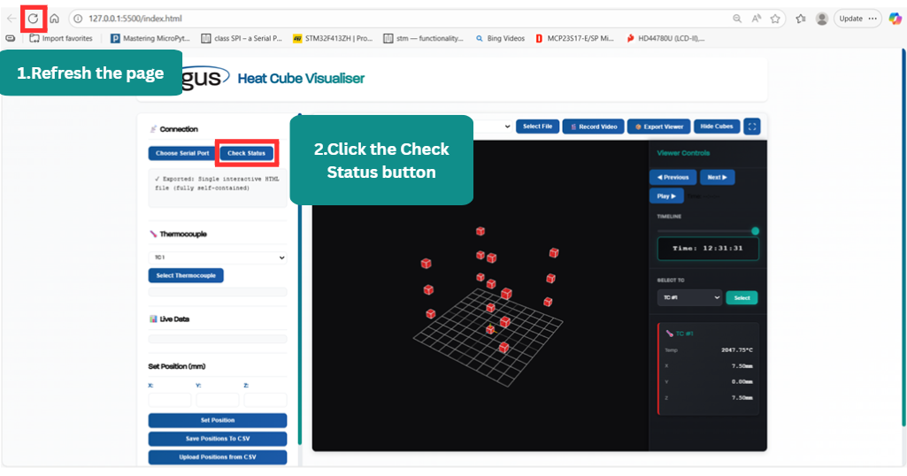

Figure 43: Refresh and Check Status.

Restart the Thonny code by clicking the red **Stop** button, then click the green **Run** button to start it again.

Check the PowerShell terminal in VS Code to see if it has stopped. If it has stopped, activate the terminal input preparing to type. Then press **Ctlr + C** to clear it and then type **node copy-backend.js**. **(See** Figure 44 **for an example).**

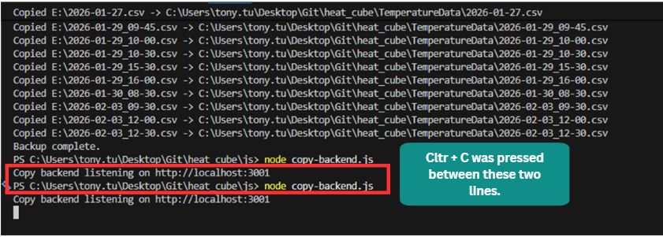

Figure 44: Debug JavaScript terminal.

If the terminal needs to be viewed, right-click on an empty region in the browser and then click **Inspect.** (See Figure 45).

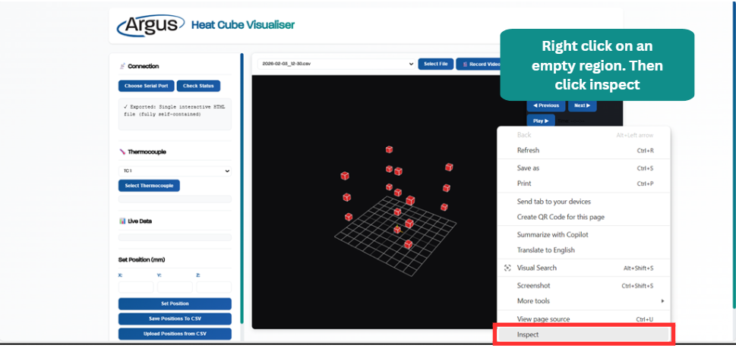

Figure 45: Where to find Inspect.

Click the **Console** icon as shown in Figure 46. This displays the console log, where debug messages can be viewed.

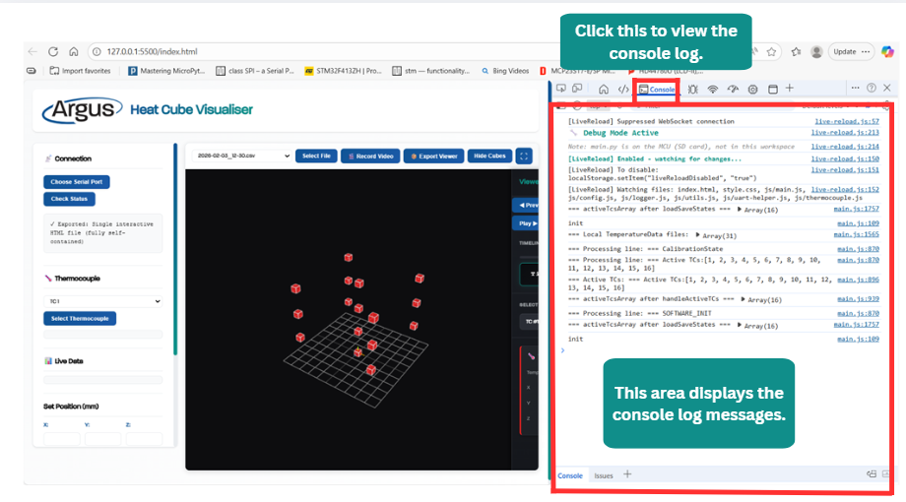

Figure 46: Console log messages in the browser.

## Full reset of local storage on browser

To fully reset the browser and clear the local storage, type the command **localStorage.clear();** at the end of **main.js** (see Figure 47).

In the example shown in Figure 47**,** this command would be typed on line 2448. After the browser refreshes, delete the line.

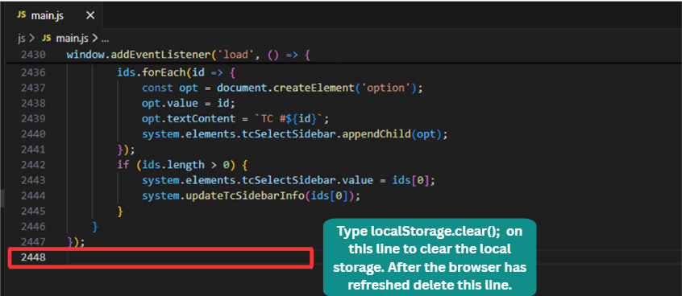

Figure 47: Where to type to clear and reset local storage.

# 10 | Common Issues

Below are several common issues that may arise, along with their possible solutions.

**Issue: Cannot view thermocouple data, or buttons are unresponsive**

**Solutions:**

Verify that the Python code is running and you are hosting the server on VS code. To verify this click **Check Status** the Python shell should restart and display text like Figure 25.

Refer to Section 6.1 for additional troubleshooting steps.

**Issue: Files are corrupted.**

**Solution:**

Safety delete all the files from the SD card, then copy the latest version of **SR_Code** back onto the SD card.

* The folder containing this code is shown in Figure 48.

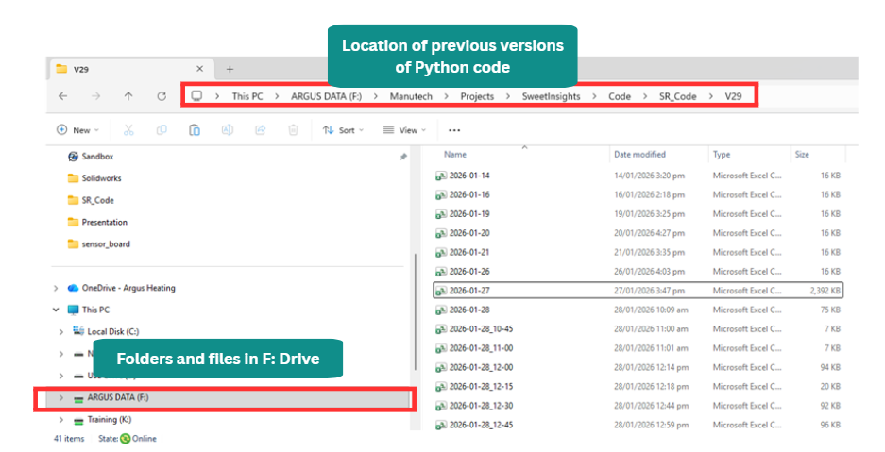

Figure 48: SR Code Location.

**Issue: Just cannot get things to work.**

**Solution:** Check all connections, verify the code is running and inspect the wiring to ensure nothing has been unplugged. If further help is needed, ask.

**Issue: A newly recorded data file does not appear in the dropdown list**

**Solution:** Confirm that **node copy-backend.js** is typed and the server is running in VS Code’s terminal. If so, check the terminal messages to see that the file was copied over. Refresh the page afterward.

**Issue: The 3D Scene is frozen**

**Solution:** Refresh the page to reload

**Issue: All the cubes on the browser scene are red.**

Solution: No thermocouples are connected.

**Issue: The scene is black with no visible cubes.**

**Solution**: The camera view is likely positioned either too close to or too far from the cubes. Zoom in or pan the scene to relocate the cubes. If the issues persist, preform a full browser reset by following section **7.1 .**

**Issue: JavaScript code was modified accidentally as cannot be restored manually.**

**Solution:** Revert to a previous working version in Git, which will be labelled something like **“Working with SR Code V29”**. Then copy the commit ID from the highlighted section shown in Figure 49.

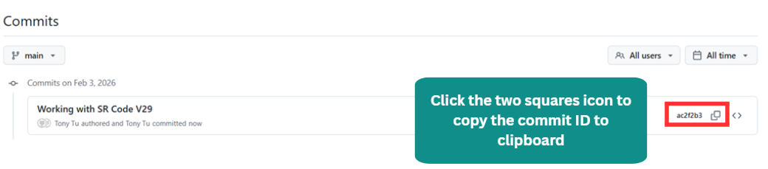

Figure 49: Previous commits

Then right-click the project folder on your laptop and click **Open in Terminal**. (See Figure 50)

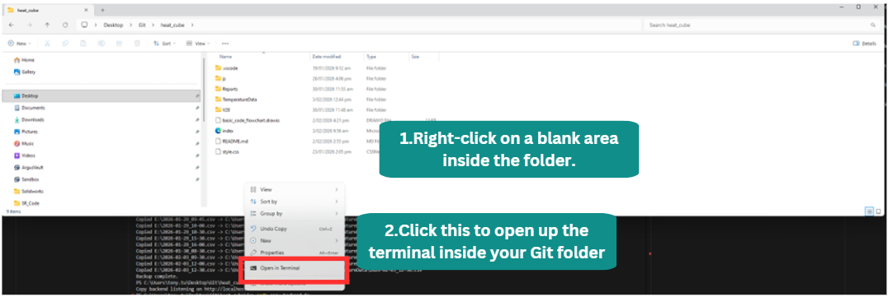

Figure 50; Right clicking inside the folder to open the terminal.

Type the command **git reset --hard <commit_ID>** using the commit ID you want to revert to (e.g.,  
**git reset --hard ac2f2b345d15403049c703a3175b1caf4e8c9e55**) into the terminal.

Then type git status to confirm that the repository has returned to the desired version.

This step is shown in Figure 51. The terminal output will appear similar to the example displayed.

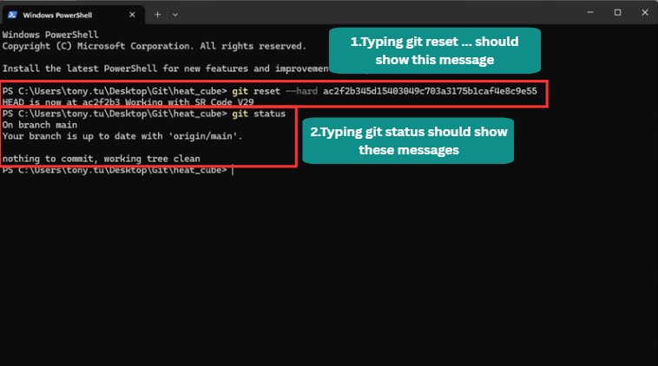

Figure 51: Git commands.

# 11 | Requirements

Thonny IDE for the MCU code – This has python installed on it.

VS Code IDE (optional) for working with JavaScript code

**Required extensions for VS Code:**

* Live Server
* GitHub Copilot Chat (optional, if AI assistance is desired)

**These extensions are highlighted in Figure 52.**

Node JS – For hosting a server to copy files over

Git (Optional) – Version control.

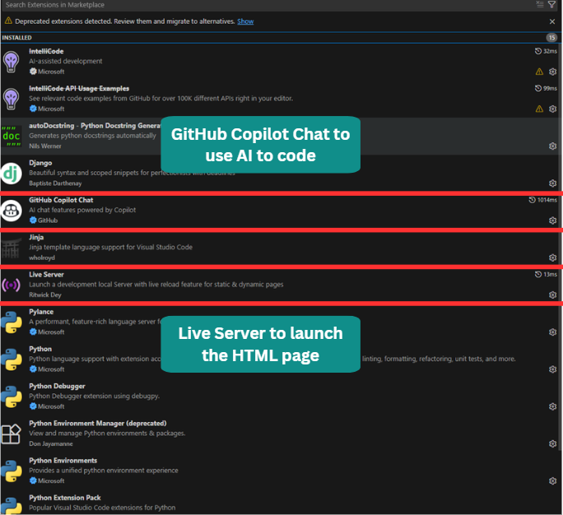

Figure 52: Extensions for VS Code.

# 12 | How to debug and add new features easily: AI

Using AI to debug code and add new features can be helpful, but it is a double‑edged sword.

**You need to be more specific about what you want AI to do: an example of this is like:**

*“I want you to add a feature of a timeline where the user is able to first select a file to view and then is able to scroll a timeline and view the datapoints stored in that file with the first column representing the time that data was recorded and equal column after that represents the temperature data for that cube so second column is the temperature data for the first cube. Then alongside this the colour of that cube will change depending on the designated temperature and be updated on the scene…”*

**Instead of just:**

*“Add a timeline scroller thing”*

Since AI requires context to understand the intended task, it will otherwise attempt to do what it ***thinks*** you want.  
If an issue is encountered, it is often better to first consider how you would approach the solution yourself, then explain to Copilot the steps needed to identify and fix the problem.  
Otherwise, the AI may make the issue worse, though not always.